Tinder Architecture -
1. Store Profile
2. Recommend matches
3. Note matches
4. Direct Messaging
Storing Images -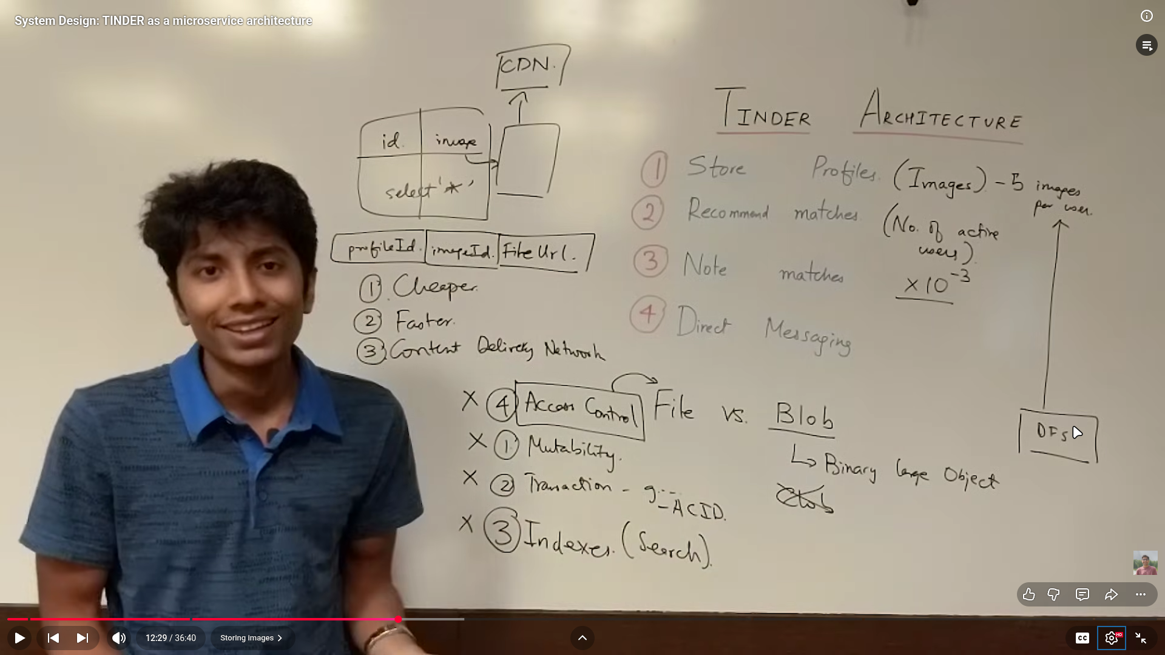

Direct Messaging ->

Note Matches ->
Recommendation System ->


